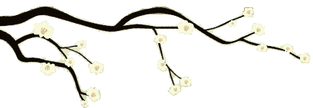

# *Session 4 Three Minute Breathing Space*

[Bong]

Taking a breathing space.

Making a definite change in your posture, so it embodies a sense of being awake.

Perhaps closing the eyes, if that's possible.

[Breath]

And beginning step one, by seeing what is going on in your mind and body right now.

What's the weather pattern like inside?

[Breath]

What thoughts are around?

[Breath]

What feelings are here?

[Breath]

Any sensations in the body?

[Breath]

Not trying to change anything but opening to what's already here.

[Breath]

Then moving to step 2, bringing the attention to the breath.

Narrowing the spotlight of attention on, sensations of breath in the abdomen.

Tuning into the changing physical sensations of the in breath, for its full duration and the out breath for its full duration.

And if the mind wanders simply acknowledging where it went and gently escorting it back to the breath.

[Breath][Breath][Breath]

And now step three, expanding the focus of your awareness around the breath to take in the whole body.

As if the whole body were breathing now.

Aware of your posture, your facial expression, sensations on the surface of the skin and from right inside the body.

[Breath]

Holding in awareness all the sensations in your body, just as they are

[Breath]

Coming home to the body

[Breath]

Coming home to this moment.

[Breath]

[Bong]